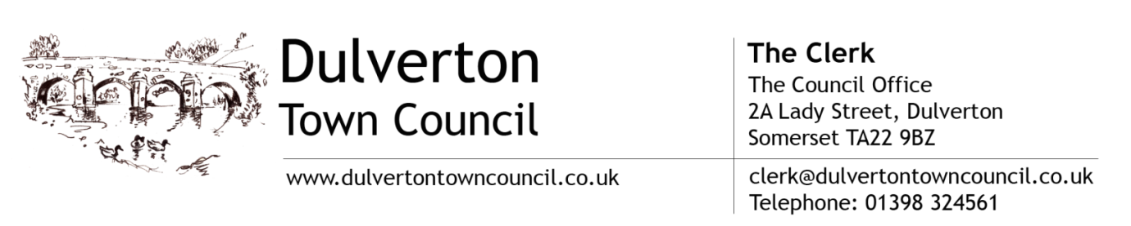

Minutes of the Planning Committee meeting held on Thursday 3rd September 2020 at 6.30pm, using remote video conferencing.

Present: Chairman: Cllr. Mrs Margaret Rawle; Cllrs: Mr Gerry Lewis; Mr John Preston; Miss Kathryn Vellacott and Mr Piers Wood.

Apologies: None

Deferment of business for comment by the public. None

Declarations of Interest:
Cllr. Mr Piers Wood – Re: Planning Application 6/9/20/108

The Chairman advised that Item 5 will be moved to the end of the meeting.

Planning Applications:

Exmoor National Park Authority:

6/9/20/109, 6/9/20/110 and 6/9/20/111:

RESOLVED: To adopt as part of this meeting the comments as per Appendix A Proposed by Mrs Rawle, seconded by Mr Preston and carried.

6/40/19/101: Amended plans notification - Proposed installation of 15m telecommunications mono pole mast and associated equipment together with twin wheel access track. (FULL)
Halse Farm, Halse Lane, Winsford, Somerset.

Observations: No objections, however members consider that better use could be made of the mast/pole to provide improved internet coverage.

6/9/20/112: Proposed formation of balcony and installation of doors to proposed balcony. (HOUSEHOLDER)
28C, Lady Street, Dulverton TA22 9DA

Observations: Members consider that the proposed depth of the balcony will greatly impact and be intrusive to those walking along the leat path. They object to the structure overhanging the leat and suggest that a ‘Juliet’ style balcony would be more appropriate.
Furthermore they find the use of timber to be bulky and would prefer to see the structure made from iron, in keeping with the neighbouring property.

Somerset West. & Taunton Planning Authority:

6/9/20/002: Land between No’s 6 & 8 Battleton, Dulverton TA22 9HT

Observations: Members are aware that the deadline for comment has passed however would like to endorse comments made subsequently by local residents.
Members agree that the proposals do not meet existing regulations as imposed by Highways. Visibility with regard oncoming traffic when exiting the property will be restricted and present hazardous driving conditions for oncoming traffic.

Refusals: None

Withdrawals: None

Correspondence:

Galloway Estates Ltd., Chartered Surveyors on behalf of Consultation Airwave Solution Ltd: Re: Proposed Base Station Site Upgrade, Liscombe, Somerset TA22 9QA.
Invitation to comment on the proposals during pre-application discussions.
Noted.

NALC – Consultation on Planning for the Future White Paper: To consider a response to recommend to full Council.
Members agree with views expressed by Cllr Steven Pugsley at the recent Exmoor Panel Meeting concerning the opinion of the ENP, that the proposals are not likely to have a major impact with regards planning within the Authority, however they may affect rural exception sites, i.e. the number of affordable homes delivered for local people.
They concluded that they were unable to contribute further.

Cllr. Mr Piers Wood left the meeting.

Final Approvals:

6/9/20/108: Proposed change of use from A2 to a mixed use comprised of a community radio station, a recording studio and a black box studio theatre.
National Westminster Bank PLC, 6, Bank Square, Dulverton Somerset TA22 9BU. (CONDITIONAL)

6/9/20/109: Proposed erection of single storey extension. Re-submission of refused application ref 6/9/19/1212
10 Amory Road, Dulverton, TA22 9DY (CONDITIONAL)

Date of next meeting: To be determined.

Chairman .............................................................................

